

Database Management System Project

Event Management System

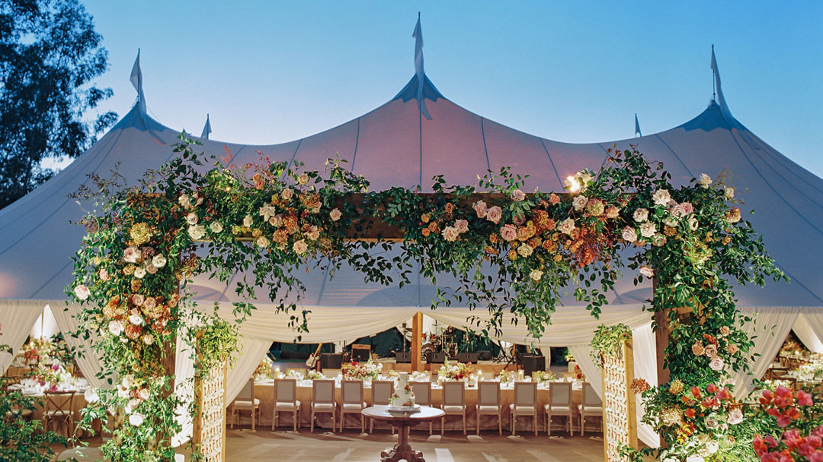

Submitted to:

Dr. Shelly Sachdeva

Submitted by:

Abhishek Yadav (201210003)

Priyanka Sehra (201210034)

Riha Kokode (201210036)

ACKNOWLEGDEMENT

On completion of this project on ‘Event Management System’, we would like to express our heartfelt gratitude to Dr. Shelly Sachdeva, our course instructor for the course on Database Management System, for giving us this project as an opportunity to learn through first-hand work experience and providing her excellent guidance that has helped us throughout.

We would also extend our thankfulness to our Teaching Assistants, Ms. Kanika Soni, Mr. Satyam Sagar and Mr. Anil Kumar, for providing their valuable assistance and advice that have played a vital role in completing this project.

This project has been extremely useful for us to learn a lot about Database Management Systems and related topics. Through this project, we learned a lot about the use and implementation of DBMS in our real world. It has not only helped in broadening our horizons but has also provided us exposure to real-life projects and their usefulness.

We thank our course coordinator and faculties for giving us such an amazing and enriching experience.

CONTENT

1. Case Study
2. Introduction
3. System Requirements
4. ER Diagram (Previous)
5. ER Diagram (Updated)
6. Mapping from ER Model to R Model
7. Relational Schema
8. Data Dictionary
9. SQL Queries
10. Populated Tables
11. DB Connectivity
12. Functionalities
13. Bibliography

Case Study

Currently there are a lot of destination weddings, parties and events happening. The host of the event has to go venue to venue to check the availability of the day and a lot of time and money is put into it. While organising an event, customers have to put in a lot of effort to fetch small details such as checking the capacity of the venue or the menu options.

Event planning firms have to go through a lot of paperwork to manage the expenses of an event and supplier payments. They have to attend to every customer individually to explain to them the event's plan.

Managing records of the customers takes a lot of time and effort as there isn’t a proper system for the same.

Growing interests in destination weddings, parties and events have created a need for a management system which can help both the customer and the administrator to manage their time and resources.

Hence, we have created an online platform to make managing events easier for customers as well as the event management companies. We have used a database management system to maintain the integrity of data, to remove data redundancy and for faster data retrieval.

INTRODUCTION

This project on the Event Management System has been made primarily using the concepts of Database Management System. We have tried to make a system that cites all the information related to the venues available, food varieties, and other related staff and officials concerned with the organising of the event. Additionally, it also serves as a portal to register and plan an event.

We provide a single platform to view a variety of venues and menus without using much of the customers’ time and effort. We deliver detailed information about the expenses of the event and services which helps in maintaining the transparency. All information regarding payments and expenditure are maintained using the database management system.

Our website produces favourable search results in accordance with the client’s requirements. There are many venues dedicated to certain types of events. We classify the venues according to type of event, respective capacities of venues, theme of venues, and type of food menu available, destination of venues.

This system maintains the record of expenses done and staff available and their contact details. Customers have to register to book an event. After registration/login they can contact different departments and can even give feedbacks.

SYSTEM REQUIREMENTS

Hardware Requirements:

* Processor: Core2 Duo.
* Primary Memory: 1 GB or Higher RAM.
* Secondary Memory: 50 GB of Hard Disk Space
* Microsoft Windows 10
* A Modem and Internet connection

Software Requirements:

* The front-end has been developed by the use of HTML, CSS and JS.
* MySQL has been used as a back-end query language.
* PHP has been chosen as a scripting language.
* Web Browser (Chrome/Edge/Firefox etc.)
* XAMPP
* MySQL

ASSUMPTIONS

* We have create single login page for both admin and customers.
* We have assumed the person logged in is the organizer of the event.
* We have assumed that the user does not cancel their booking.
* We have assumed that a user book only one order at a time.

ER DIAGRAM (Previous)

<https://erdplus.com/>

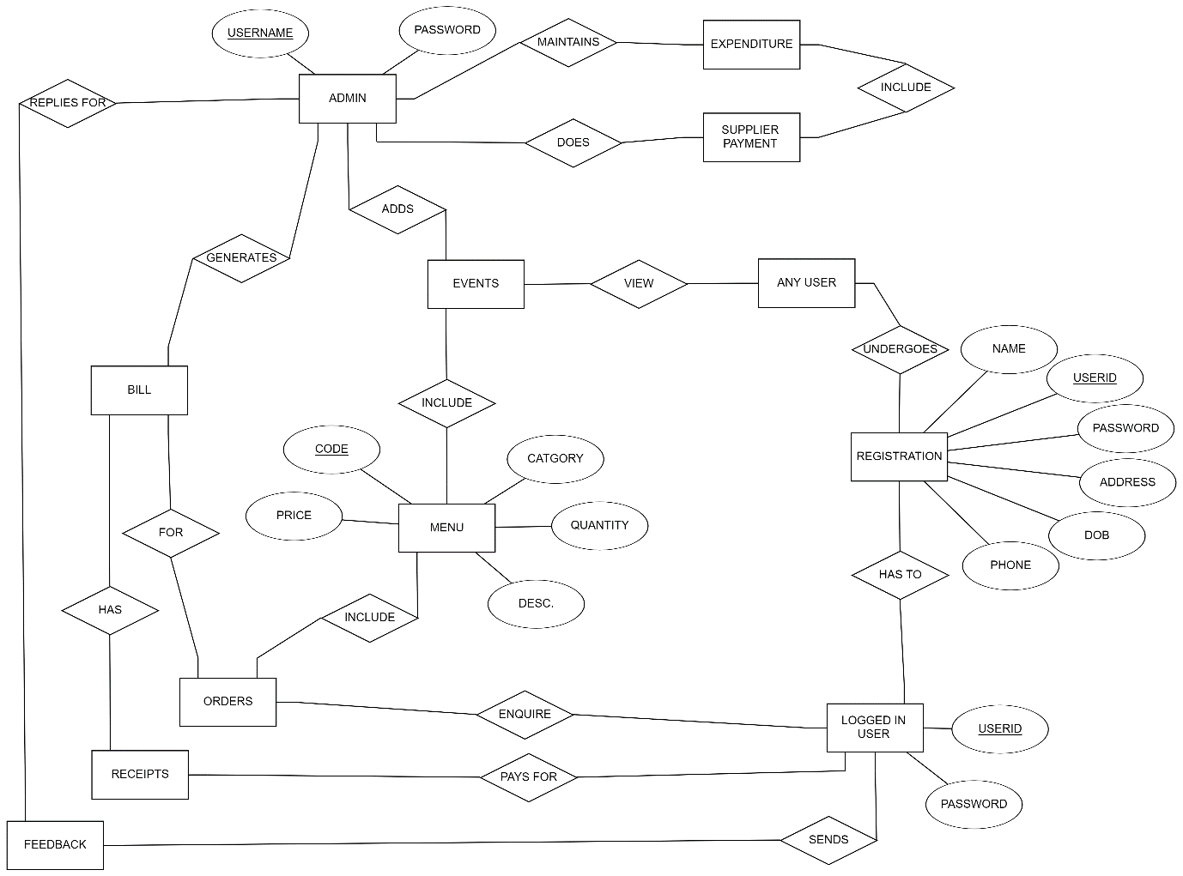

ER Diagram (Updated)

<https://cloud.smartdraw.com/>

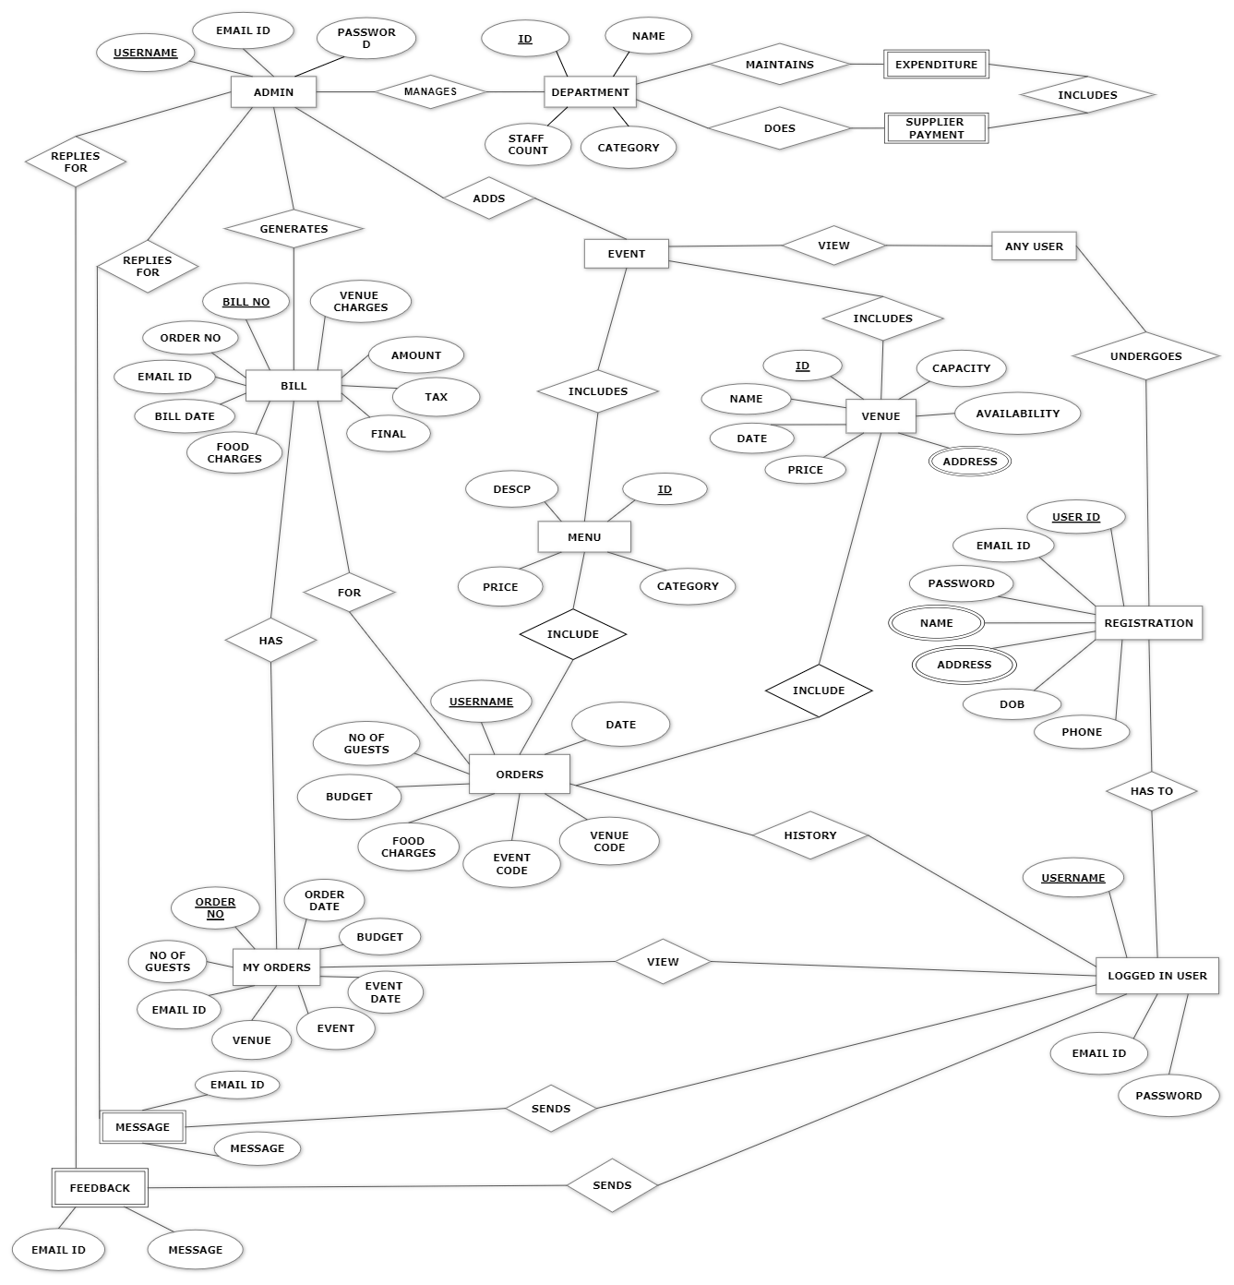

N

M

N

1

1

M

M

N

1

N

N

N

1

1

1

N

M

N

M

N

N

M

N

N

M

N

1

1

1

1

1

1

1

1

1

1

1

1

1

1

1

1

MAPPING FROM ER MODEL TO R MODEL

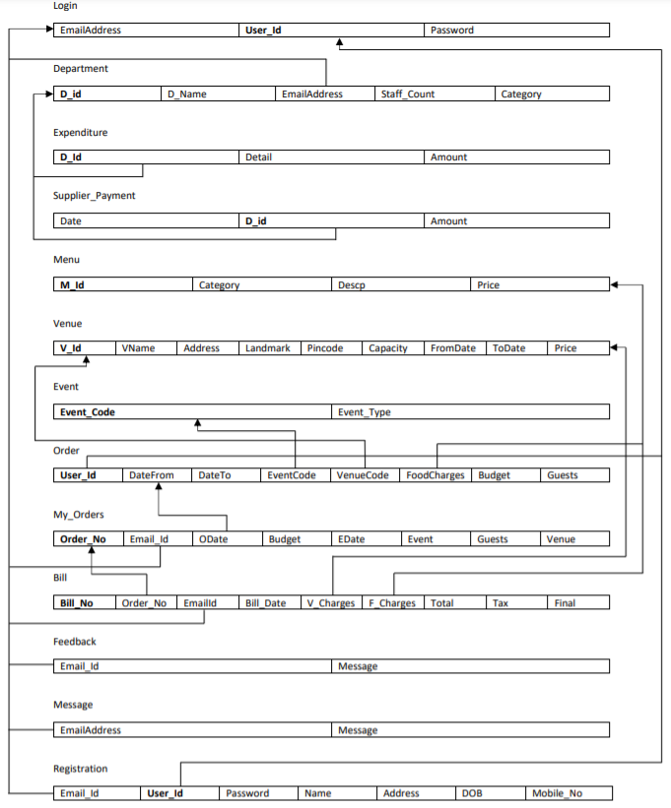

Relational Schema

<https://dbdiagram.io>

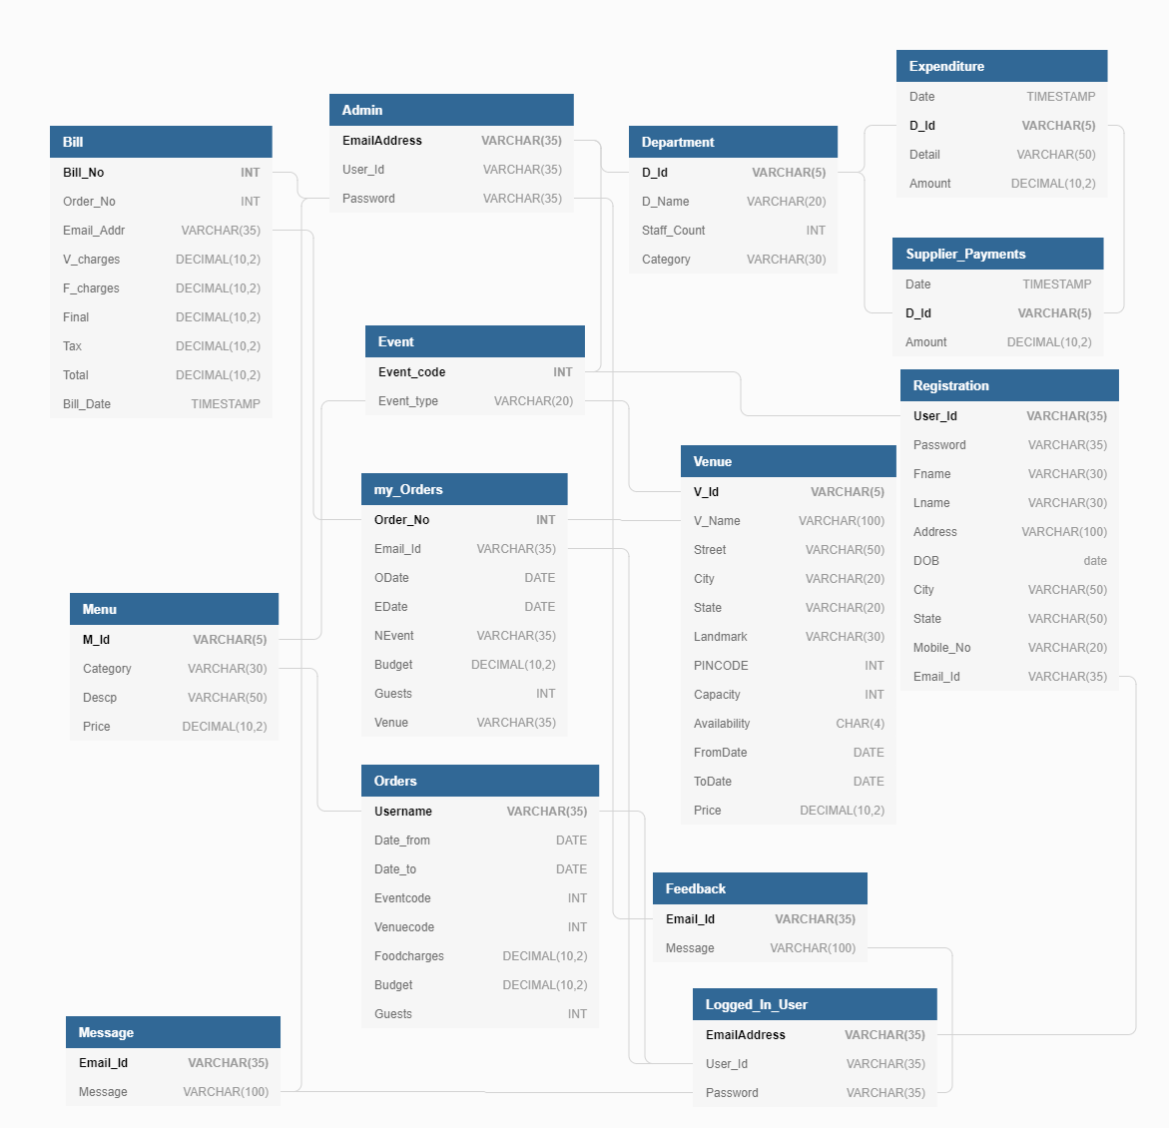

Data Dictionary

1. **Bill:**

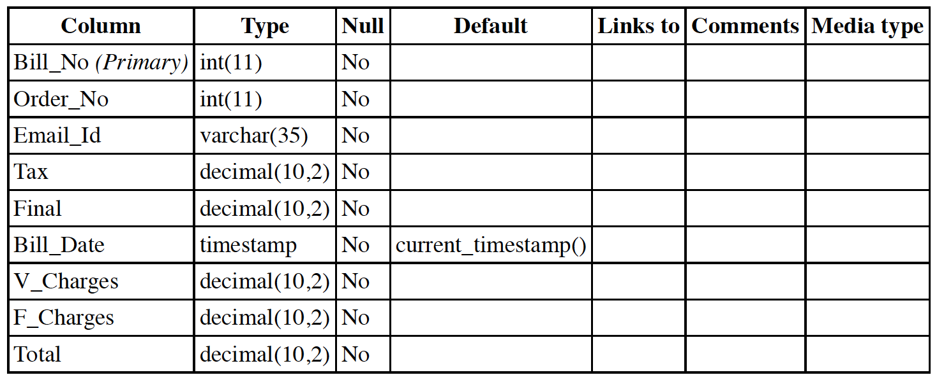

Indexes:

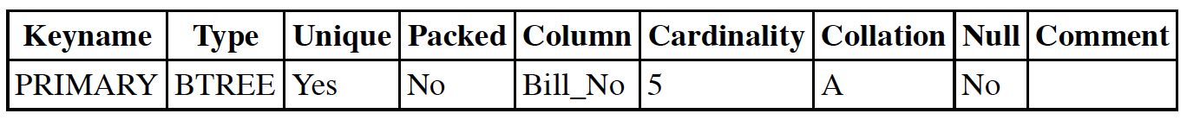

**2. Department:**

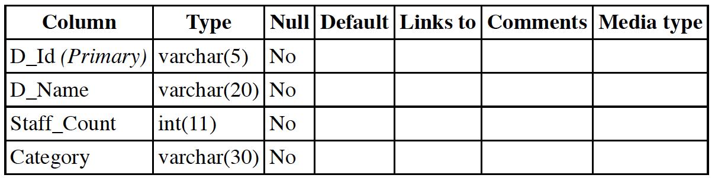

Indexes:

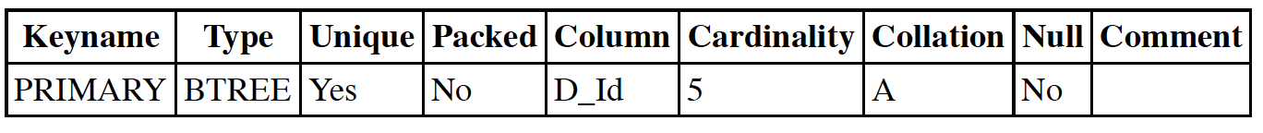

**3. Event:**

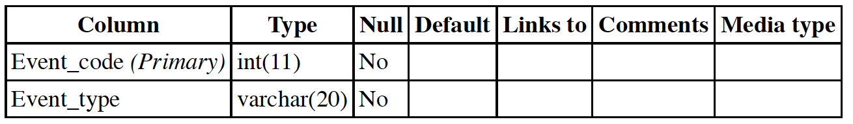

Indexes:



**4. Expenditure:**

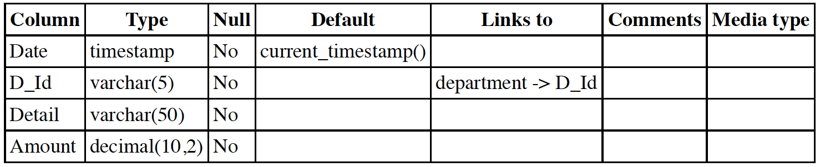

Indexes:

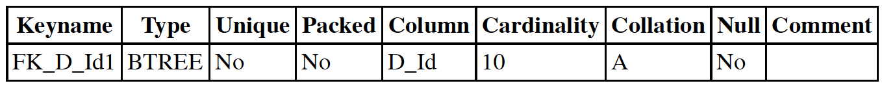

**5. Feedback:**

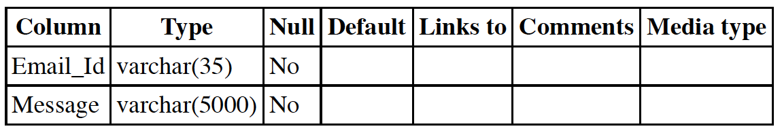

**6. Message:**

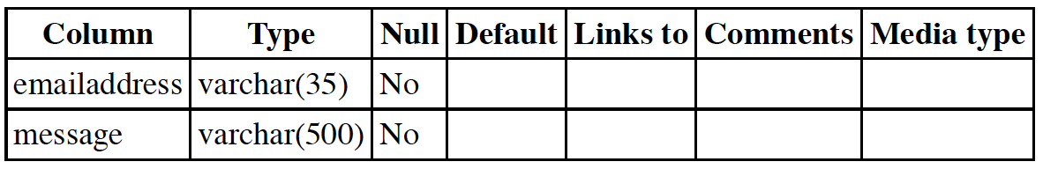

**7. Login:**

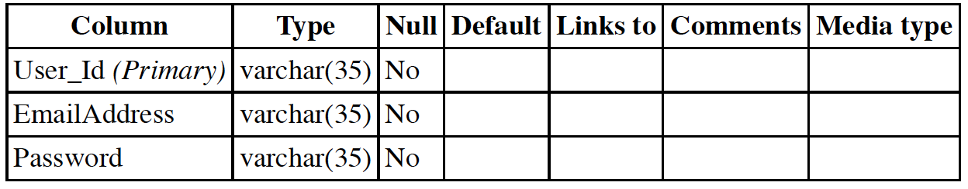

Indexes: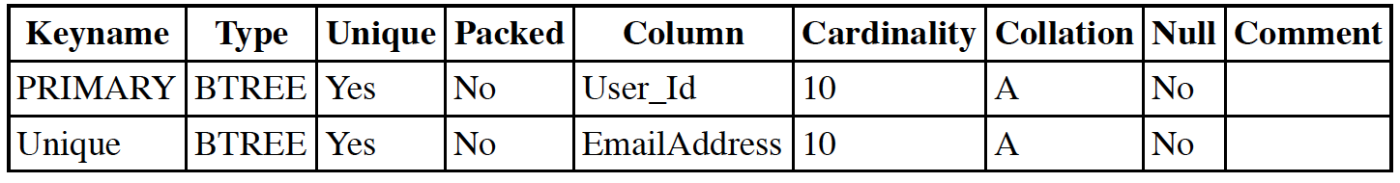

**8. Menu:**

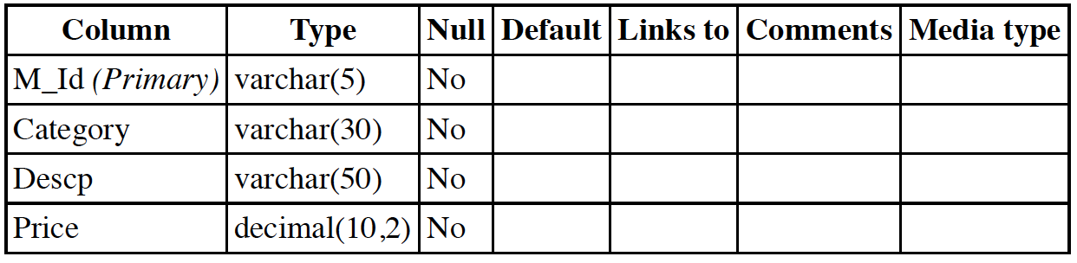

Indexes:



**9. My Orders:**

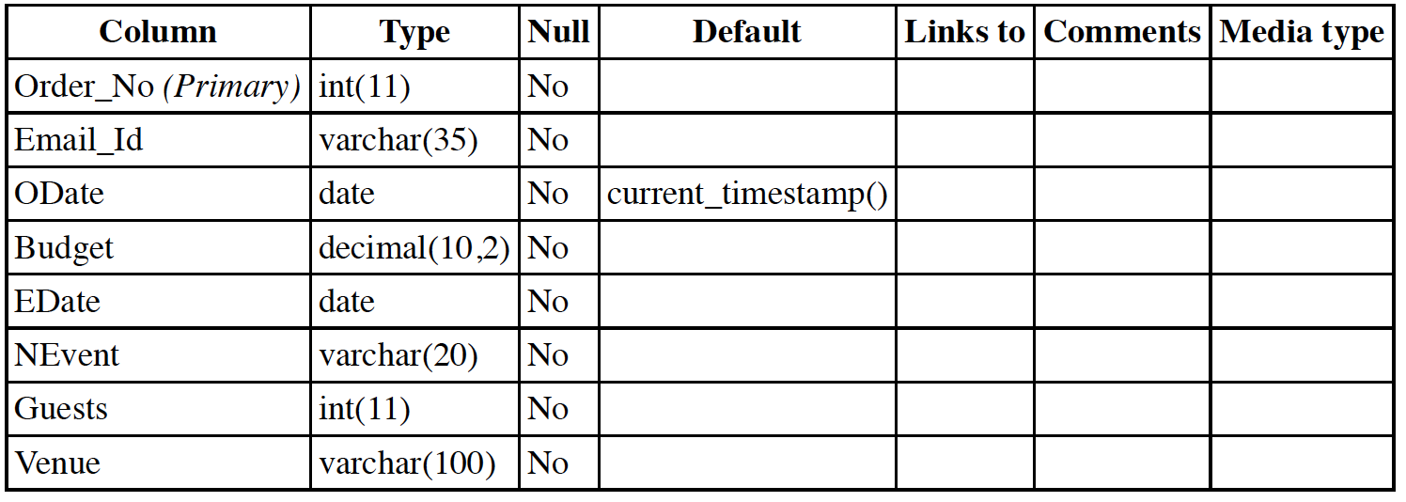

Indexes:

**10. Orders:**

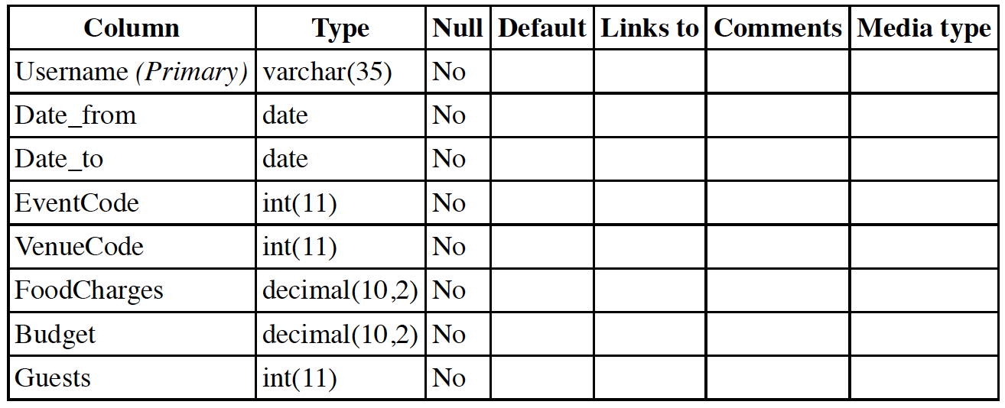

Indexes:



**11. Registration:**

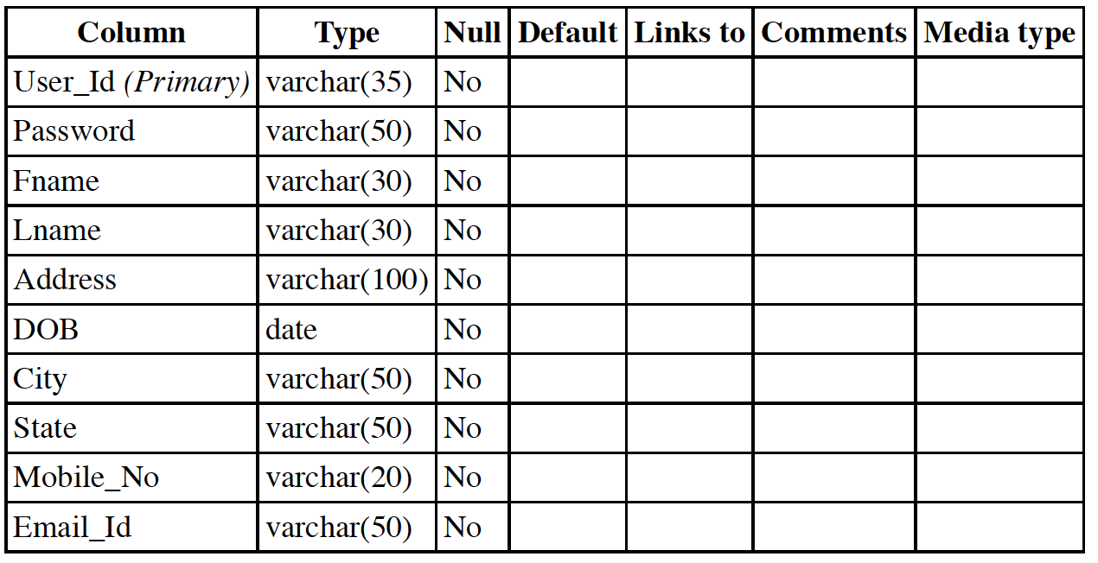

Indexes:

**12. Supplier Payments:**

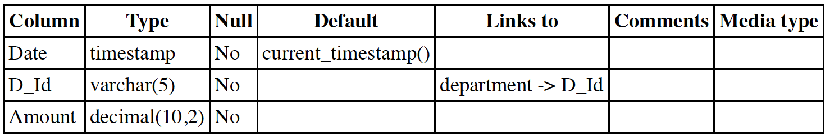

Indexes:

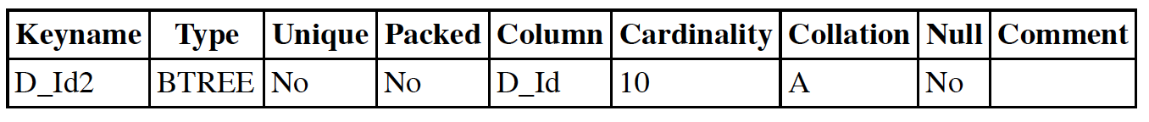

1. 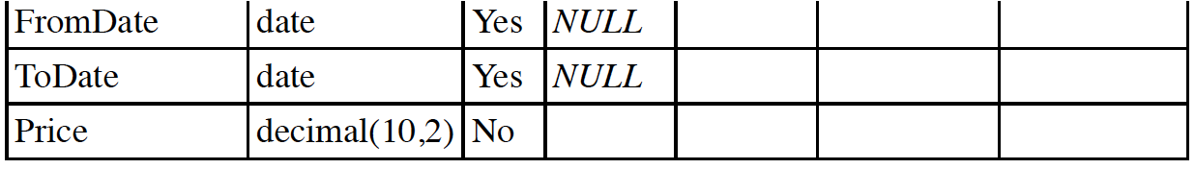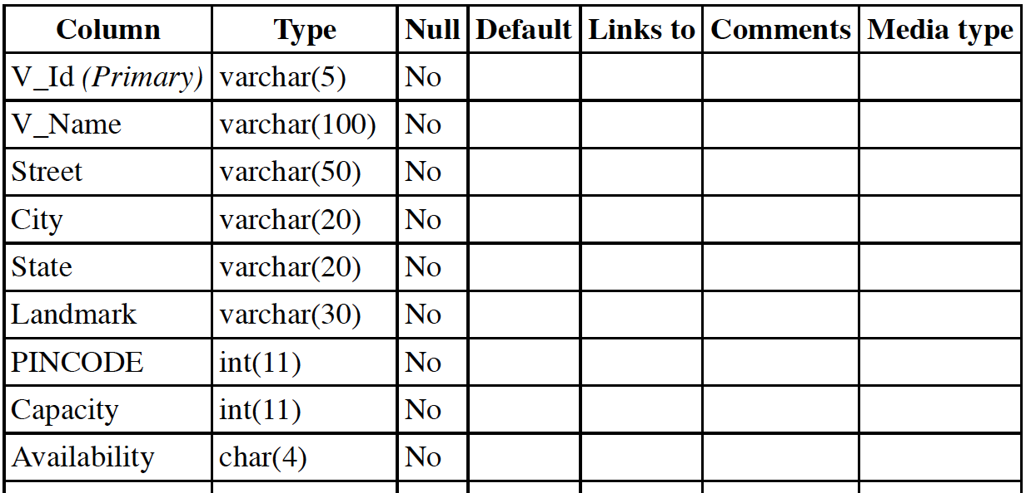 **Venue:**

Indexes:

**SQL QUERIES**

**CREATING DATABASE:**

CREATE DATABASE RAP;

|  |  |  |
| --- | --- | --- |
| **TABLE NAME** | **OPERATION** | **QUERY** |
| 1. Bill | CREATE | CREATE TABLE ‘bill’  (  `Bill_No` int(11) NOT NULL,  `Order_No` int(11) NOT NULL,  `Email_Id` varchar(35) NOT NULL,  `Bill_Date` date NOT NULL DEFAULT current_timestamp(),  `V_Charges` decimal(10,2) NOT NULL,  `F_Charges` decimal(10,2) NOT NULL,  `Total` decimal(10,2) NOT NULL,  `Tax` decimal(10,2) NOT NULL,  `Final` decimal(10,2) NOT NULL  ); |
| INSERT | INSERT INTO ‘bill’ (`Bill_No`, `Order_No`, `Email_Id`, `Bill_Date`, `V_Charges`, `F_Charges`, `Total`, `Tax`, `Final`)  VALUES  (4458, 1103, 'atul@gmail.com', '2021-09-23', '1000000.00', '840000.00', '1840000.00', '368000.00', '2208000.00'),  (4506, 1101, 'jatin@gmail.com', '2021-11-21', '1000000.00', '842400.00', '1842400.00', '368480.00', '2210880.00'),  (4548, 1102, 'rohit@gmail.com', '2021-10-26', '800000.00', '543000.00', '1343000.00', '268600.00', '1611600.00'); |
| 2. Events | CREATE | CREATE TABLE `event`  (  `Event_code` int(11) NOT NULL,  `Event_type` varchar(20) NOT NULL  ); |
| INSERT | INSERT INTO `event` (`Event_code`, `Event_type`) VALUES  (1000, 'BIRTHDAY'),  (1001, 'WEDDING'),  (1002, 'Shower'),  (1003, 'Conference'),  (1004, 'seminar'),  (1005, 'Workshop'),  (1006, 'Sponsorship'),  (1007, 'Trade show'),  (1008, 'Networking event '),  (1009, 'guest speaker'); |
| 3. Feedback | CREATE | CREATE TABLE `feedback`  (  `Email_Id` varchar(35) NOT NULL,  `Message` varchar(100) NOT NULL  ); |
| INSERT | INSERT INTO `feedback` (`Email_Id`, `Message`) VALUES  ('shadab@gmail.com', 'the staff was really great and was doing the work nicely '),  ('atul@gmail.com', 'I cant thank R-A-P enough the make my sons birthday great'),  ('shweta@gmail.com', 'I couldnt go any better place to celebrate '),  ('rohit@gmail.com', 'Everything was so perfect'),  ('jatin@gmail.com', 'I was too tense for my daughters wedding but they made everything smooth'),  ('tushar@gmail.com', 'a great massive respect for RAP team '),  ('yukta@gmail.com', 'the staff was doing every thing so nicely, I thought its there sons birthday '); |
| 4. Login | CREATE | CREATE TABLE `login`  (  `User_Id` varchar(35) NOT NULL,  `EmailAddress` varchar(35) NOT NULL,  `Password` varchar(35) NOT NULL  ); |
| INSERT | INSERT INTO `login` (`User_Id`, `EmailAddress`, `Password`)  VALUES  ('abhi9560', 'abhi@gmail.com', '9700000001'),  ('atul0607', 'atul@gmail.com', '9700000005'),  ('jatin487', 'jatin@gmail.com', '9700000008'),  ('reaha866', 'riha@gmail.com', '9700000003'),  ('rohit482', 'rohit@gmail.com', '9700000007'),  ('shadab123', 'shadab@gmail.com', '9700000004'),  ('shweta48', 'shweta@gmail.com', '9700000006'),  ('tushar012', 'tushar@gmail.com', '9700000009'),  ('yukta102', 'yukta@gmail.com', '9700000010'),  ('zyx789', 'priyanka@gmail.com', '9700000002'); |
| 5. Menu | CREATE | CREATE TABLE `menu`  (  `M_Id` varchar(5) NOT NULL,  `Category` varchar(30) NOT NULL,  `Descp` varchar(50) NOT NULL,  `Price` decimal(10,2) NOT NULL  ); |
| INSERT | INSERT INTO `menu` (`M_Id`, `Category`, `Descp`, `Price`)  VALUES  ('M101', 'main course', 'Paneer Pasanda', '250.00'),  ('M102', 'main course', 'Dal Bukhara', '200.00'),  ('M103', 'main course', 'Zafrani Pulao', '250.00'),  ('M104', 'starter', 'Indo-Chinese', '150.00'),  ('M105', 'starter', 'Dahi Bhalle', '100.00'),  ('M106', 'bevarage', 'Cold Drinks', '40.00'),  ('M107', 'starter', 'Aloo ki tikki', '70.00'),  ('M108', 'starter', 'Litti Chokha', '150.00'),  ('M109', 'sweet dish', 'Chocolate Fondue', '100.00'),  ('M110', 'starter', 'Pasta Primavera', '120.00'),  ('M111', 'apetizer', 'Salad', '320.00'); |
| 6. Message | CREATE | CREATE TABLE `message` (  `EmailAddress` varchar(35) NOT NULL,  `Message` varchar(500) NOT NULL ); |
| INSERT | INSERT INTO `message` (`EmailAddress`, `Message`)  VALUES  ('rohit@gmail.com', 'Can you provide me the detailed information about the venue \"Radisson Blu Hotel\"?\r\n'); |

|  |  |  |
| --- | --- | --- |
| 7. My_orders | CREATE | CREATE TABLE `my_orders`  (  `Order_No` int(11) NOT NULL,  `Email_Id` varchar(35) NOT NULL,  `ODate` date NOT NULL DEFAULT current_timestamp(),  `Budget` decimal(10,2) NOT NULL,  `EDate` date NOT NULL,  `NEvent` varchar(20) NOT NULL,  `Guests` int(11) NOT NULL,  `Venue` varchar(100) NOT NULL  ); |
| INSERT | INSERT INTO `my_orders` (`Order_No`, `Email_Id`, `ODate`, `Budget`, `EDate`, `NEvent`, `Guests`, `Venue`)  VALUES  (1101, 'jatin@gmail.com', '2021-11-20', '3000000.00', '2021-11-30', 'Workshop', 156, 'Radisson Blu Hotel'),  (1102, 'rohit@gmail.com', '2021-10-12', '2000000.00', '2021-10-29', 'Networking event', 220, 'Royale Farmhouse'),  (1103, 'atul@gmail.com', '2021-09-22', '2500000.00', '2021-09-21', 'BIRTHDAY', 350, 'OWL Club'); |
| 8. Orders | CREATE | CREATE TABLE `orders`  (  `Username` varchar(35) NOT NULL,  `Date_from` date NOT NULL,  `Date_to` date NOT NULL,  `EventCode` int(11) NOT NULL,  `VenueCode` varchar(5) NOT NULL,  `FoodCharges` decimal(10,2) NOT NULL,  `Budget` decimal(10,2) NOT NULL,  `Guests` int(11) NOT NULL  ); |
| INSERT | INSERT INTO `orders` (`Username`, `Date_from`, `Date_to`, `EventCode`, `VenueCode`, `FoodCharges`, `Budget`, `Guests`)  VALUES  ('atul0607', '2021-09-21', '2021-09-21', 1000, 'V08', '840000.00', '2500000.00', 350),  ('jatin487', '2021-11-30', '2021-12-04', 1005, 'V01', '842400.00', '3000000.00', 156),  ('rohit482', '2021-10-29', '2021-10-29', 1008, 'V05', '543000.00', '2000000.00', 220); |
| 9. Registration | CREATE | CREATE TABLE `registration`  (  `User_Id` varchar(35) NOT NULL,  `Password` varchar(50) NOT NULL,  `Fname` varchar(30) NOT NULL,  `Lname` varchar(30) NOT NULL,  `Address` varchar(100) NOT NULL,  `DOB` date NOT NULL,  `City` varchar(50) NOT NULL,  `State` varchar(50) NOT NULL,  `Mobile_No` varchar(20) NOT NULL,  `Contact_NO` varchar(20) NOT NULL,  `Email_Id` varchar(50) NOT NULL  ); |
| INSERT | INSERT INTO `registration` (`User_Id`, `Password`, `Fname`, `Lname`, `Address`, `DOB`, `City`, `State`, `Mobile_No`, `Contact_NO`, `Email_Id`) VALUES  ('atul0607', '9700000005', 'ATUL', 'GOYAL', 'H.No. 154, faridkot', '2002-07-06', 'Kotakpura', 'Punjab', '8478596125', '7845961487', 'atul@gmail.com'),  ('jatin487', '9700000008', 'JATIN', 'SHARMA', 'H.No. 04, Newtown', '2001-08-25', 'Kolkata', 'West Bengal', '8148965478', '6478931548', 'jatin@gmail.com'),  ('rohit482', '9700000003', 'ROHIT', 'SINGH', 'H.No. 487, Jalahalli', '2000-04-21', 'Bangalore', 'Karnataka', '7456321548', '9784561549', 'rohit@gmail.com'),  ('shadab123', '9700000004', 'SHADAB', 'AGWAN', 'H.No. 79, Sangam Vihar', '2002-11-20', 'Najafgarh', 'New Delhi', '8457964125', '9784563214', 'shadab@gmail.com'),  ('shweta48', '9700000006', 'SHWETA', 'GAHLAWAT', 'H.No. 123, Panchkula', '2001-09-27', 'Panchkula', 'Haryana', '9874589656', '6485794578', 'shweta@gmail.com'),  ('yukta102', '9700000010', 'YUKTA', 'RANA', 'H.No. 105, Sector 13', '2001-12-09', 'Dwarka', 'New Delhi', '7145745896', '8453154978', 'yukta@gmail.com'); |

|  |  |  |
| --- | --- | --- |
| 10. Venue | CREATE | CREATE TABLE `venue`  (  `V_Id` varchar(5) NOT NULL,  `V_Name` varchar(100) NOT NULL,  `Street` varchar(50) NOT NULL,  `City` varchar(20) NOT NULL,  `State` varchar(20) NOT NULL,  `Landmark` varchar(30) NOT NULL,  `PINCODE` int(11) NOT NULL,  `Capacity` int(11) NOT NULL,  `Availability` char(4) NOT NULL,  `FromDate` date DEFAULT NULL,  `ToDate` date DEFAULT NULL,  `Price` decimal(10,2) NOT NULL); |
| INSERT | INSERT INTO `venue` (`V_Id`, `V_Name`, `Street`, `City`, `State`, `Landmark`, `PINCODE`, `Capacity`, `Availability`, `FromDate`, `ToDate`, `Price`) VALUES  ('V01', 'Radisson Blu Hotel', 'Naila Bagh Palace', 'Jaipur', 'Rajasthan', 'Moti Doongri', 302007, 1500, 'NO', '2025-11-21', '2027-11-21', '500000.00'),  ('V02', 'Hammerzz Nightclub Goa', 'Calangute - Baga Rd', 'Baga', 'Goa', '-', 403516, 2500, 'YES', NULL, NULL, '600000.00'),  ('V03', 'Nyex Beach', 'Anjuna Cliff (Old Paradiso)', 'Bardez', 'Goa', '-', 403202, 2500, 'YES', NULL, NULL, '700000.00'),  ('V04', 'Sinq Night', 'Aguada Rd', 'Candolim', 'Goa', 'Taj Holiday Village', 403515, 2000, 'NO', '2020-12-21', '2025-12-21', '750000.00'),  ('V05', 'Royale Farmhouse', 'Airport Plaza, Plot No.10', 'Jaipur', 'Rajasthan', 'Radisson Blu Hotel', 302018, 2000, 'NO', '2020-11-21', '2023-11-21', '800000.00'),  ('V06', 'Camp Himachal', 'Jot Road,Talai Village', 'Chamba', 'Himachal Pradesh', '-', 176310, 1000, 'YES', NULL, NULL, '900000.00'),  ('V07', 'Leopard Valley Goa', 'Agonda Beach Rd', 'Canacona', 'Goa', 'Juggernaut Arena', 403702, 2000, 'YES', NULL, NULL, '921000.00'),  ('V08', 'OWL Club', 'Shiroli Pulachi', 'Calangute', 'Goa', 'Bagatel Boutique Hotel Goa', 403519, 2500, 'NO', '2012-01-22', '2014-01-22', '1000000.00'),  ('V09', 'Shaadi Brigade', 'Block E, Soami Nagar South', 'New Delhi', 'Delhi', '-', 110016, 2000, 'YES', NULL, NULL, '1100000.00'),  ('V10', 'NoorZa', 'Saket', 'New Delhi', 'Delhi', '-', 110017, 2500, 'NO', '2020-11-21', '2022-11-21', '1200000.00'); |
| 11. Department | CREATE | CREATE TABLE `department`  (  `D_Id` varchar(5) NOT NULL,  `D_Name` varchar(20) NOT NULL,  `EmailAddress` varchar(35) NOT NULL,  `Staff_Count` int(11) NOT NULL,  `Category` varchar(30) NOT NULL  ); |
| INSERT | INSERT INTO `department` (`D_Id`, `D_Name`, `EmailAddress`, `Staff_Count`, `Category`) VALUES  ('D01', 'RAP_WorkForce', '', 5, 'Attendant'),  ('D02', 'RAP_Gourmet', '', 10, 'Caterer_Cook'),  ('D03', 'RAP_Hosters', '', 30, 'Caterer_Server'),  ('D04', 'RAP_Floral', '', 8, 'Flower Decorator'),  ('D05', 'RAP_Cluster', '', 15, 'Seating_Planers'); |
| 12. Expenditure | CREATE | CREATE TABLE `expenditure`  (  `Date` timestamp NOT NULL DEFAULT current_timestamp(),  `D_Id` varchar(5) NOT NULL,  `Detail` varchar(50) NOT NULL,  `Amount` decimal(10,2) NOT NULL  ); |
| INSERT | INSERT INTO `expenditure` (`Date`, `D_Id`, `Detail`, `Amount`)  VALUES  ('2021-06-24 20:59:17', 'D03', 'Cuttlery', '12750.00'),  ('2021-07-25 05:02:43', 'D04', 'Flowers', '11500.00'),  ('2021-07-25 03:50:05', 'D04', 'Ribbons', '2500.00'),  ('2021-08-25 06:30:01', 'D02', 'Rice', '19050.00'),  ('2021-08-24 20:59:27', 'D05', 'Table Clothes', '12750.00'),  ('2021-09-25 02:21:01', 'D04', 'Thread', '800.00'),  ('2021-10-25 03:09:05', 'D05', 'Table', '13000.00'),  ('2021-10-25 09:29:57', 'D02', 'Vegetables', '8000.00'),  ('2021-11-25 11:49:46', 'D05', 'Chairs', '15500.00'),  ('2021-12-25 18:19:32', 'D03', 'Plates', '10065.00'); |
| 1. Supplier payments | CREATE | CREATE TABLE `supplier_payments`  (  `Date` timestamp NOT NULL DEFAULT current_timestamp(),  `D_Id` varchar(5) NOT NULL,  `Amount` decimal(10,2) NOT NULL  ); |
|  | INSERT | INSERT INTO `supplier_payments` (`Date`, `D_Id`, `Amount`)  VALUES  ('2021-05-15 00:30:00', 'D01', '200000.00'),  ('2021-03-22 11:30:00', 'D02', '150000.00'),  ('2021-10-11 06:30:00', 'D03', '950000.00'),  ('2021-01-31 03:30:00', 'D04', '80000.00'),  ('2021-11-27 04:30:00', 'D05', '125000.00'); |

Basic Queries:

|  |  |  |
| --- | --- | --- |
| **OPERATION** | **QUERY** | **SYNTAX** |
| 1. SELECT | **View venues of a specified place with the given budget:**  SELECT * FROM venue  WHERE state = "Goa" AND Price < 800000; | SELECT column1,  column2, ...  FROM table_name;  Or  SELECT * FROM  table_name; |
| **View bill details within a range of date:**  SELECT * FROM bill  WHERE bill_Date BETWEEN '2020-11-25' AND '2021-07-21'; |
| **Display events according to the capacity of guests:**  SELECT V_Name, City, State FROM Venue  WHERE Capacity BETWEEN 1000 AND 2000; |
| **Display feedback having a particular keyword:**   * SELECT * FROM Feedback   WHERE Message LIKE "%wedding%"; |
| * SELECT R.FName AS Name, F.Subject, F.Message   FROM Registration R, Feedback F  WHERE R.Email_Id = F.Email_ID AND Message LIKE "%birthday%"; |
| **For login page:**  SELECT emailaddress  FROM login  WHERE emailaddress = 'abhi@gmail.com'; |

|  |  |  |
| --- | --- | --- |
|  | **For navigation after successful login:**  SELECT FName  FROM Registration  WHERE user_id = 'atul0607'; |  |
| **Displaying details in my profile:**  SELECT FName, LName, Address, City, State, dob, mobile_No, Email_id  FROM Registration  WHERE User_Id = 'jatin487'; |
| **Displaying order details of a user:**  SELECT Order_No, ODate, Budget, EDate, Event, Guests, Venue  FROM Orders  WHERE Email_Id = ?; |
| **Displaying bill details of a user:**  SELECT Bill_No, Order_No, Bill_Date, V_Charges, F_Charges, Total, Tax, Final FROM Bill  WHERE Email_Id = ? |
| 1. UPDATE | **Updating information of logged in user:**  UPDATE Registration SET Mobile_No = '9487563484'  WHERE Fname = 'Jatin'; | UPDATE table_name SET column1 = value1,  column2 = value2, ...  WHERE condition; |
| **Special offer on any food category:**  UPDATE menu SET price = price - 20  WHERE category = 'Starter'; |
| 1. INSERT | **Adding feedback to the database:**  INSERT INTO Feedback (Email_Id, Message)  VALUES ("jatin@gmail.com", "wonderful experience"); | INSERT INTO table_name  (column1, column2,  column3, ...)  VALUES (value1, value2, value3, ...); |

Advanced Queries:

|  |  |  |
| --- | --- | --- |
| **OPERATION** | **QUERY** | **SYNTAX** |
| 1. NESTED SELECT STATEMENT | **Display all customers with due payments:**  SELECT FName, LName FROM Registration  WHERE Email_Id IN (SELECT Email_Addr FROM Bill  WHERE Bill_No IN (SELECT Bill_No FROM Receipts  WHERE Balance > 0)); | SELECT column1,  column2, ...  FROM table_name  WHERE *condition* IN (SELECT column1,  column2, ...  FROM table_name  WHERE *condition* IN…); |
| 1. SUM | **Display sum of price of all items from menu to calculate the total expense of event:**  SELECT SUM(Price) FROM Menu; | SELECT SUM(*column_name*)  FROM *table_name*  WHERE *condition*; |
| 1. COUNT | **Display food charger of a specific category of food item from the menu:**  SELECT COUNT(Descp), SUM(Price) FROM Menu  WHERE Category = "starter"; | SELECT COUNT(*column_name*)  FROM *table_name*  WHERE *condition*; |
| 1. CASE WHEN | **Display the number of customers with due payment:**  SELECT COUNT(CASE WHEN balance > 0 THEN 1 ELSE NULL END) AS CustomersWithDuePayment FROM Receipts; | SELECT COUNT(CASE WHEN *condition* THEN *output_if_true* ELSE *output_if_false* END)  FROM *table_name*; |
| 1. GROUP BY | **Display food charger category wise:**  SELECT Category, COUNT(Descp), SUM(Price) FROM Menu  GROUP BY Category; | SELECT column1,  column2, ...  FROM table_name  GROUP BY column1,  column2, ...; |

|  |  |  |
| --- | --- | --- |
| 1. ORDER BY | **Sorting order details according to order no:**  SELECT * FROM My_Orders ORDER BY Order_No; | SELECT column1,  column2, ...  FROM table_name  ORDER BY column1,  column2, ... [ASC/DESC]; |
| 1. LEFT JOIN | **Displaying the department and expenditure details:**  SELECT Department.D_Id, Department.D_Name, Expenditure.Amount  FROM Department LEFT JOIN Expenditure ON Department.D_Id = Expenditure.D_Id; | SELECT column1,  column2, ...  FROM *table1*  LEFT JOIN *table2*  ON *table1.column_name = table2.column_name;* |
| 1. RIGHT JOIN | **Displaying the department and supplier payments details:**  SELECT Department.D_Id, Department.D_Name, Supplier_Payments.Amount  FROM Department LEFT JOIN Supplier_Payments ON Department.D_Id = Supplier_Payments.D_Id; | SELECT column1,  column2, ...  FROM *table1*  RIGHT JOIN *table2*  ON *table1.column_name = table2.column_name;* |
| 1. FULL JOIN OR UNION | **Displaying the department and expenditure details:**  SELECT Department.D_Id, Department.D_Name, Expenditure.Amount  FROM Department LEFT JOIN Expenditure ON Department.D_Id = Expenditure.D_Id  UNION  SELECT Department.D_Id, Department.D_Name, Expenditure.Amount  FROM Department RIGHT JOIN Expenditure ON Department.D_Id = Expenditure.D_Id; | SELECT column1,  column2, ...  FROM *table1*  LEFT JOIN *table2*  ON *table1.column_name = table2.column_name*  UNION  SELECT column1,  column2, ...  FROM *table1*  RIGHT JOIN *table2*  ON *table1.column_name = table2.column_name;*  OR  SELECT *table1.column1, table2.column2...*  FROM *table1*  FULL JOIN *table2*  ON *table1.common_name = table2.common_name;* |

Populated database:

1. Bill

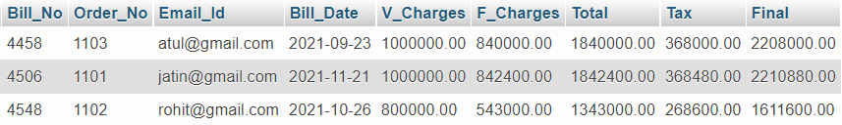

1. Department

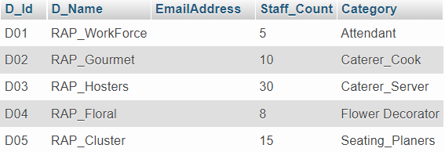

1. Event

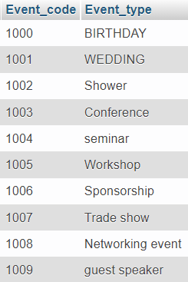

1. Expenditure

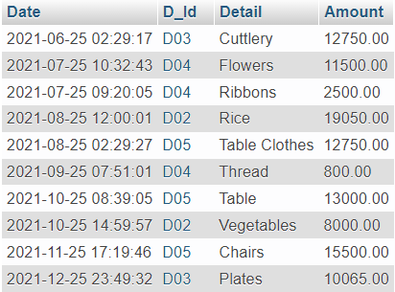

1. Feedback

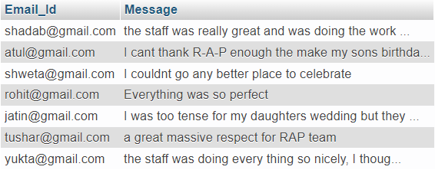

1. Login

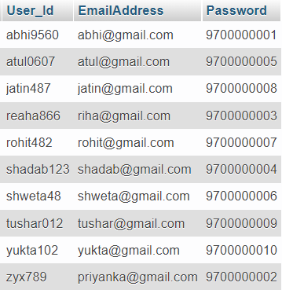

1. Menu

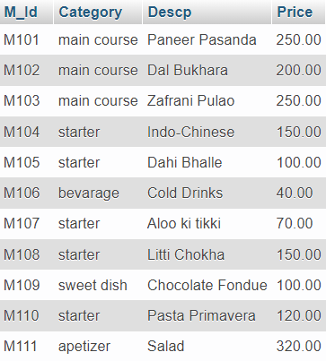

1. Message



1. My order

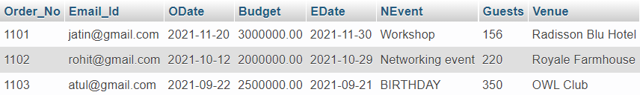

1. Orders

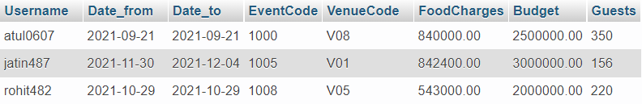

1. Registration

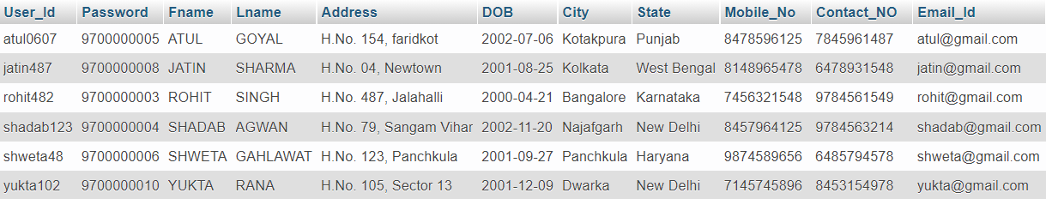

1. Supplier payments

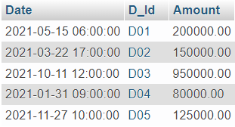

1. Venue

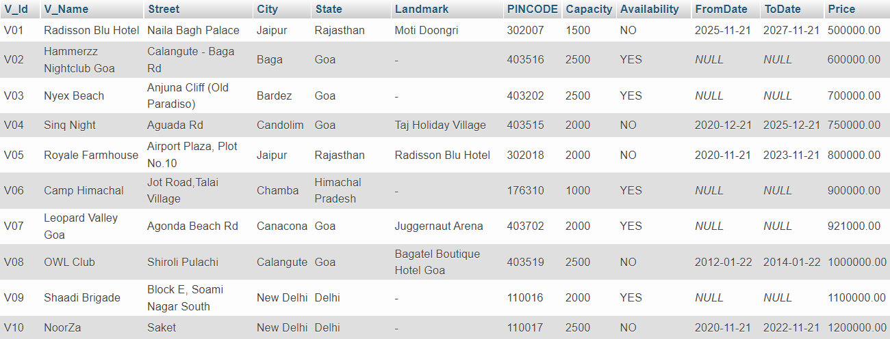

**DB Connectivity**

The database has been connected to the frontend user interface using PHP as the scripting language.

The code for establishing the connection is as follows:

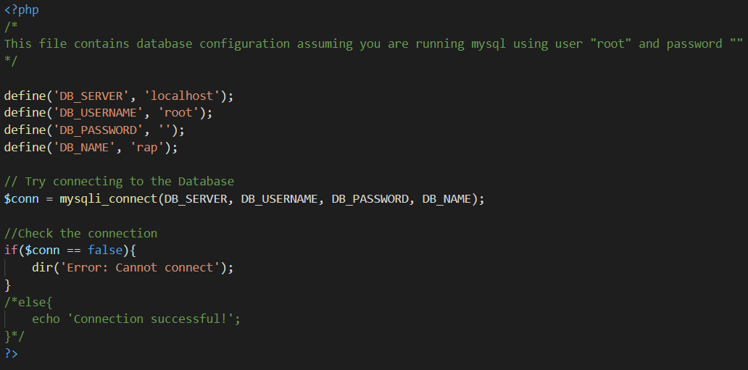

The above code serves to establish the connection between the backend (database) and frontend (user interface).

**FUNCTIONALITIES**

Following are the functionalities implemented in the project along with their respective backend PHP codes:

1. **Login Page**: The login page in common for both admin and customers.

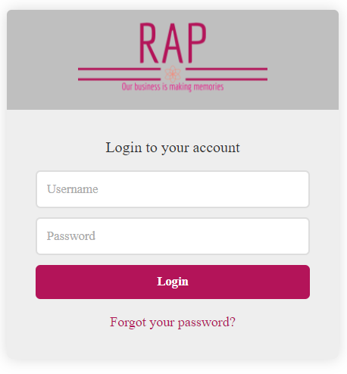

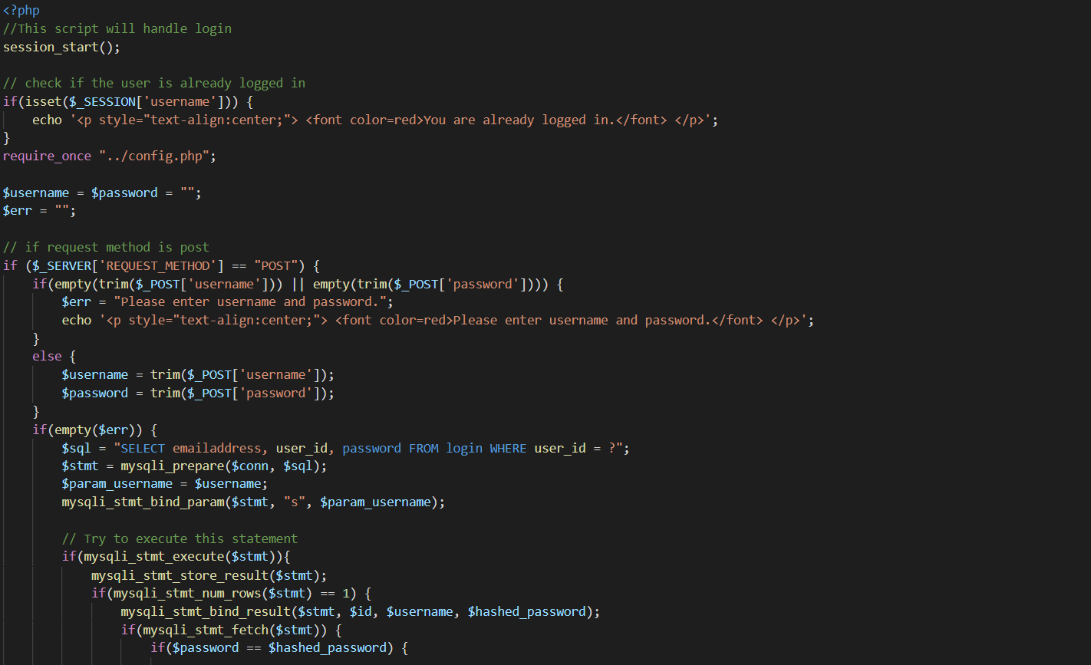

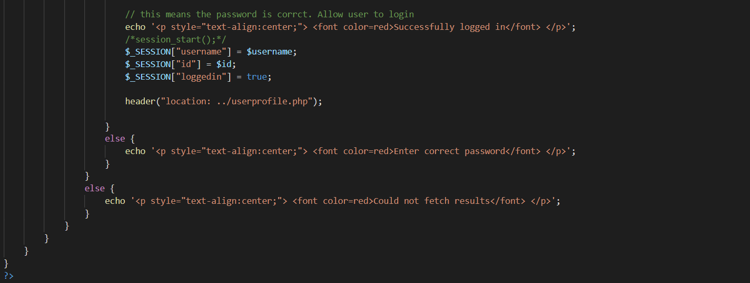

1. **Logout:**

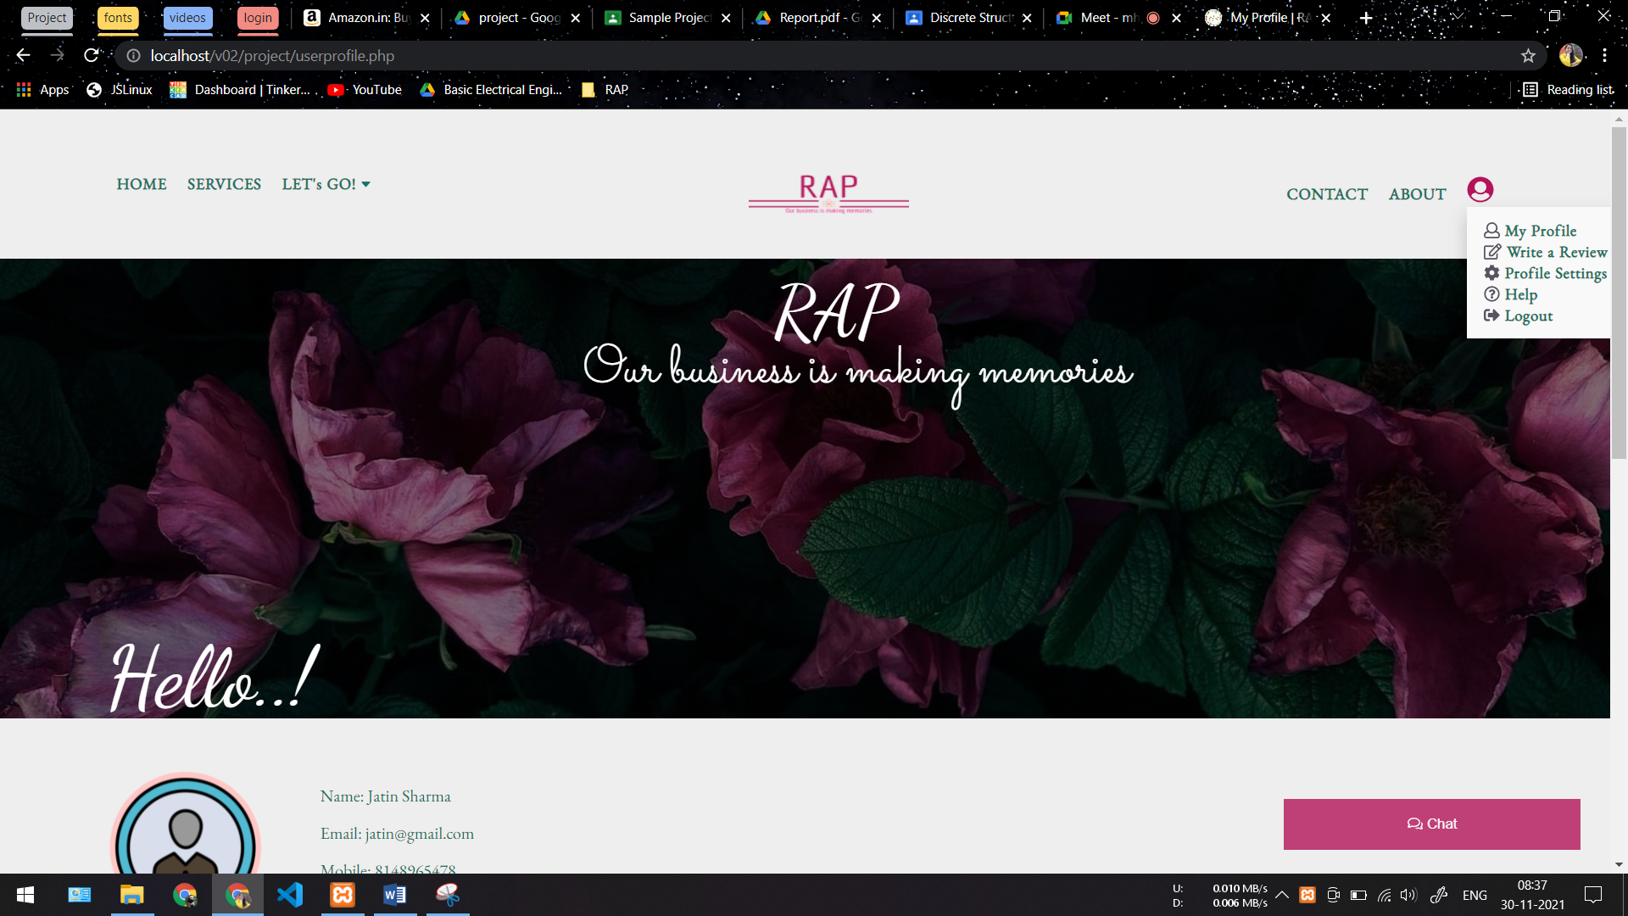

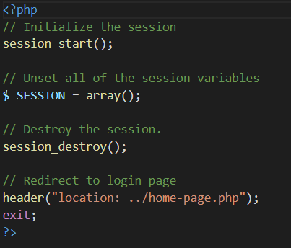

1. **My Orders page:**

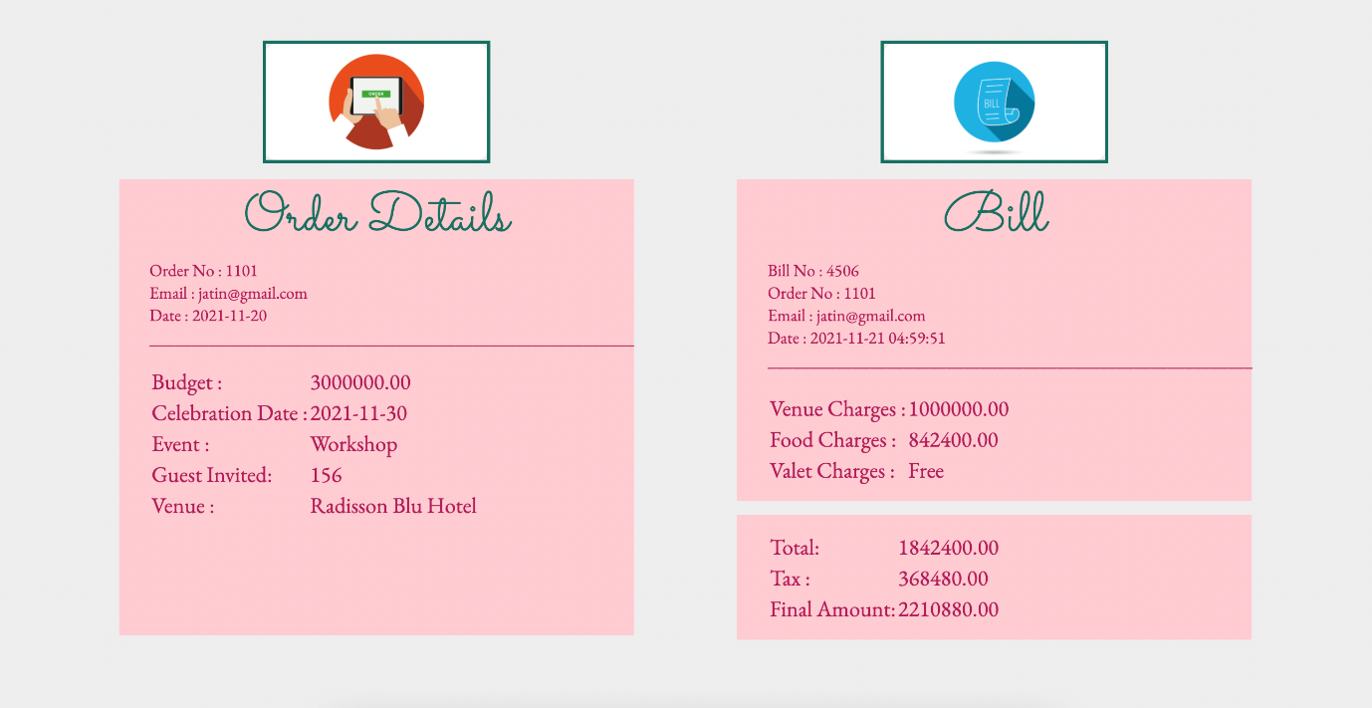

Order Details:

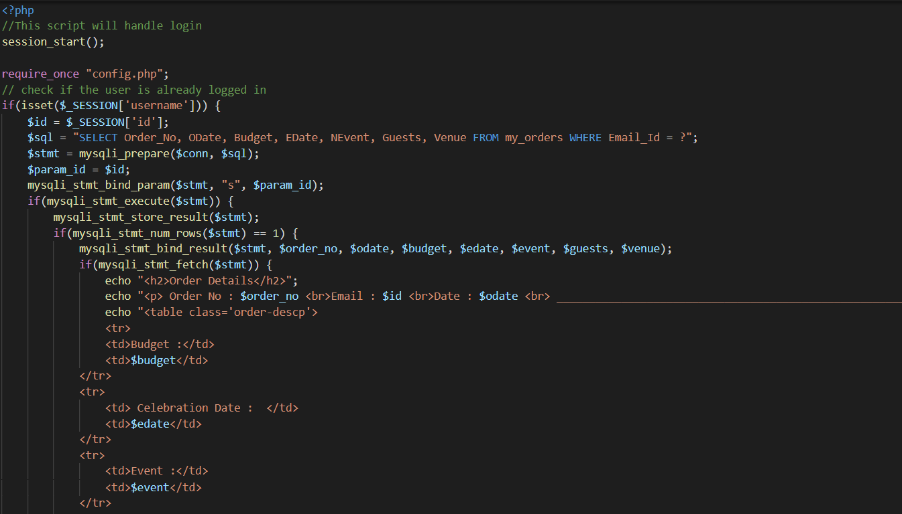

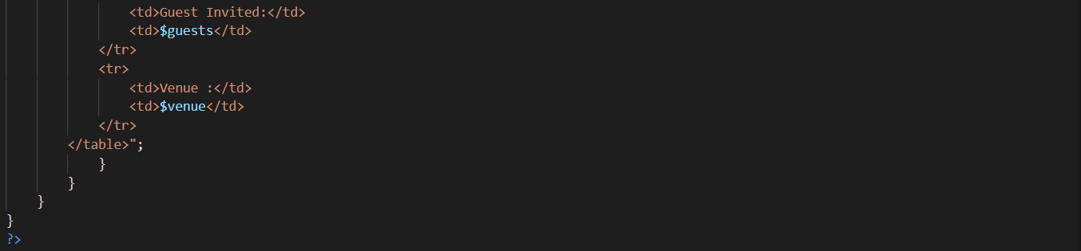

Bill Details:

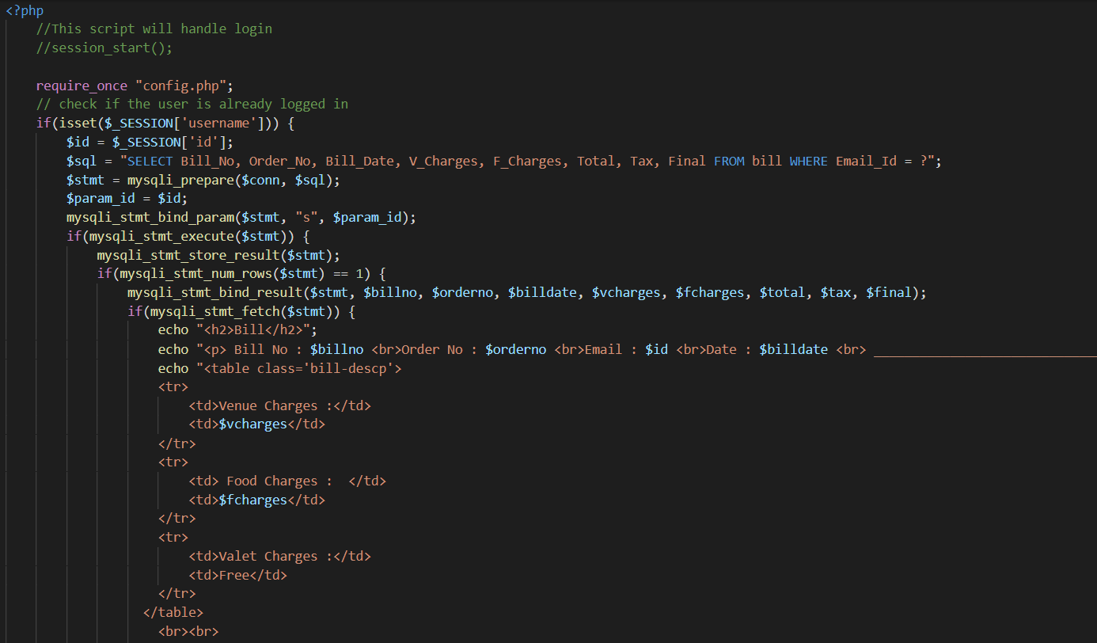

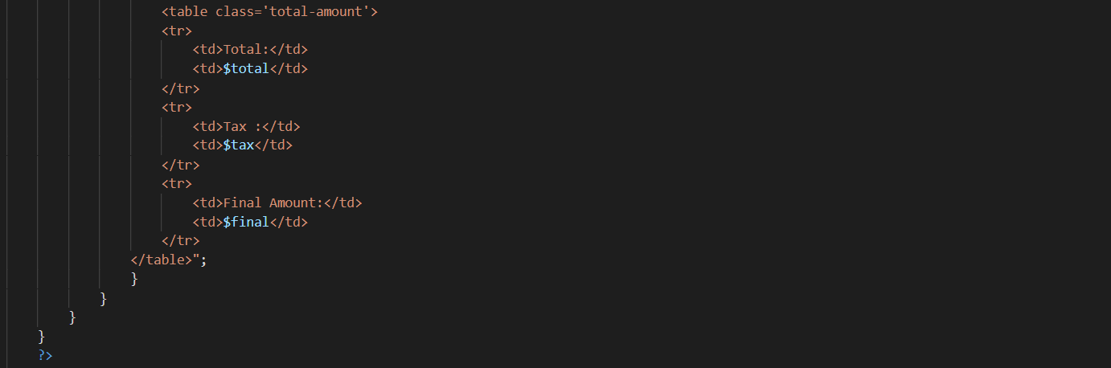

1. **My Profile Details:**

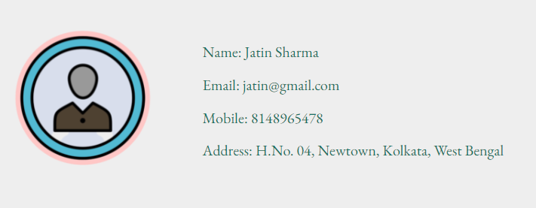

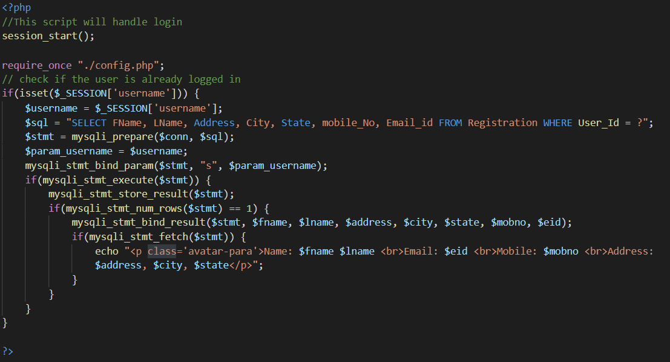

1. **Chat :**

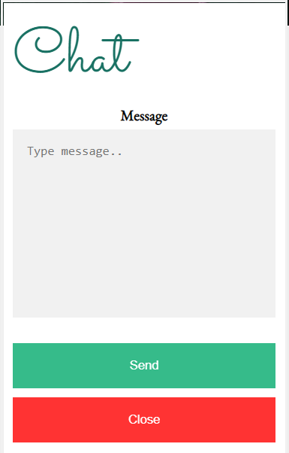

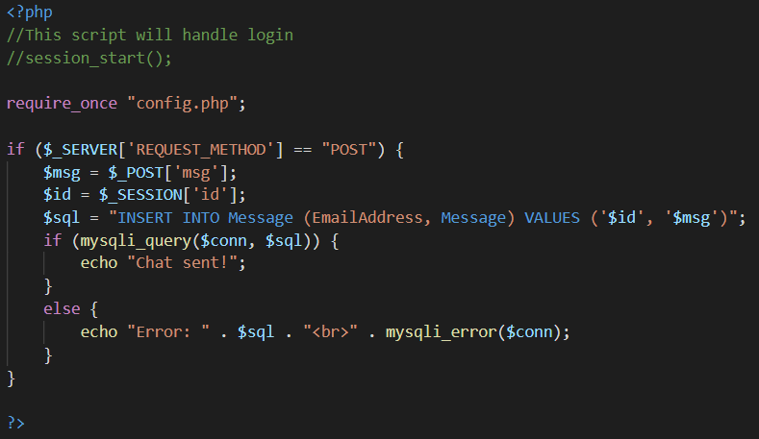

1. **Feedback:**

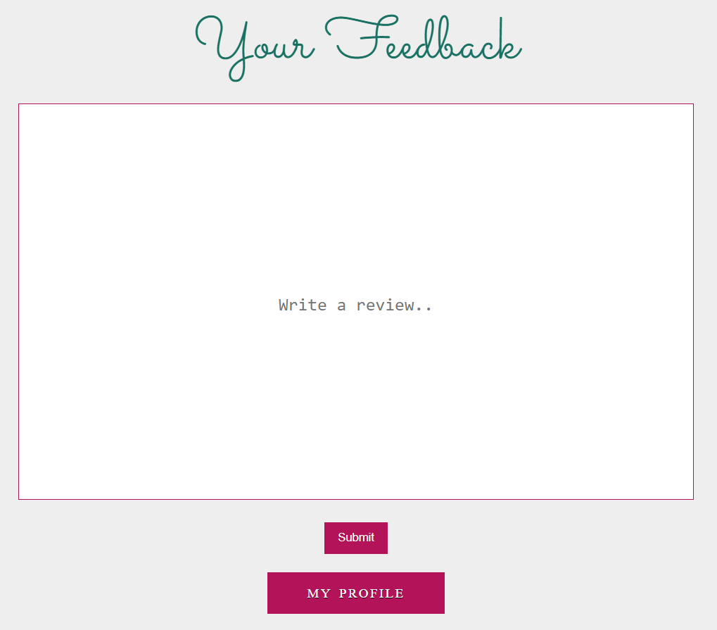

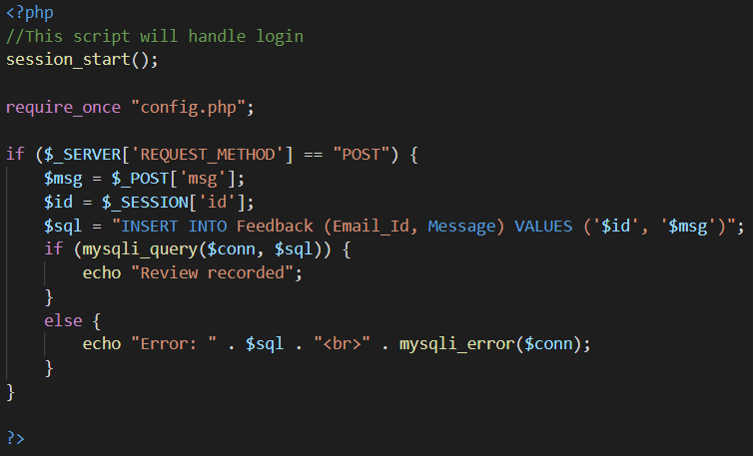

1. **Orders:**

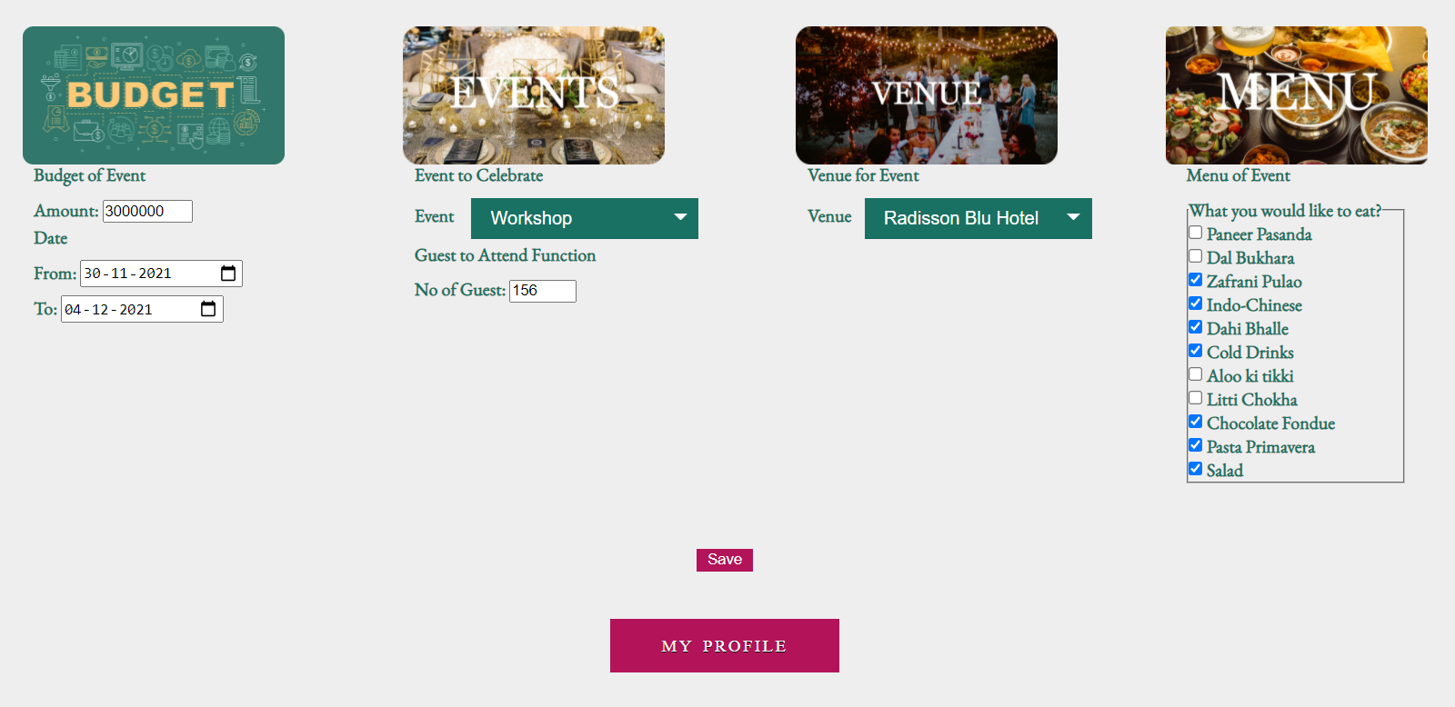

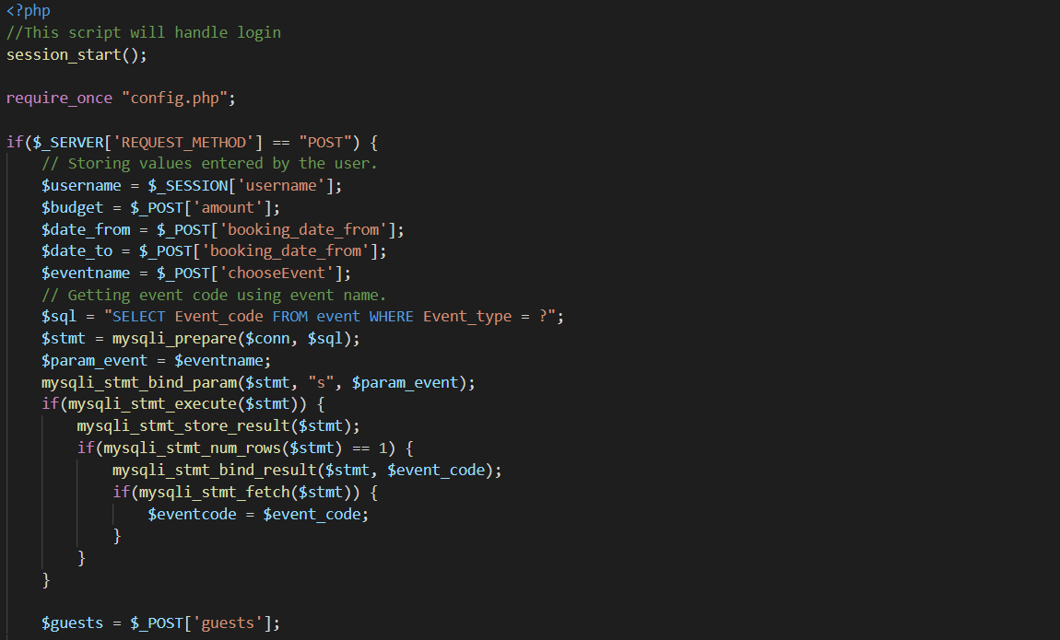

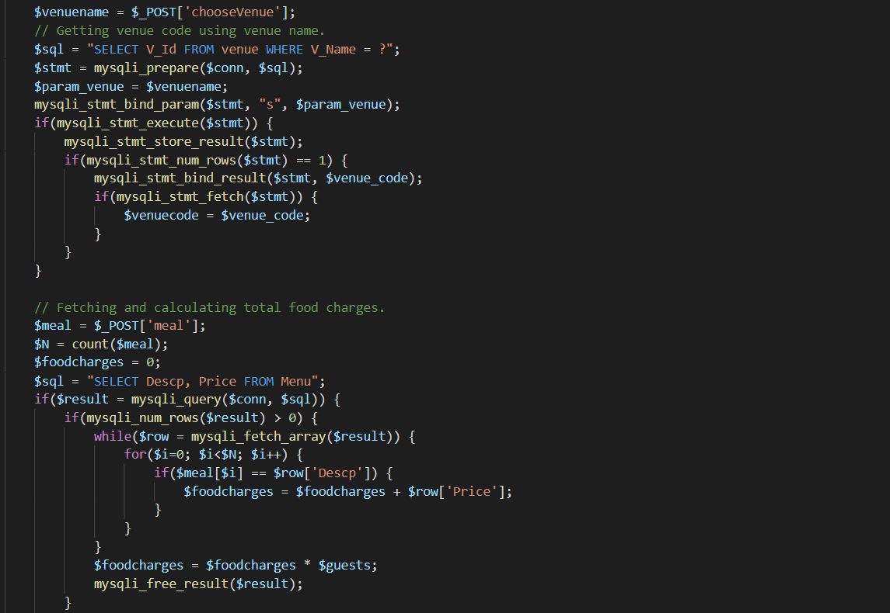

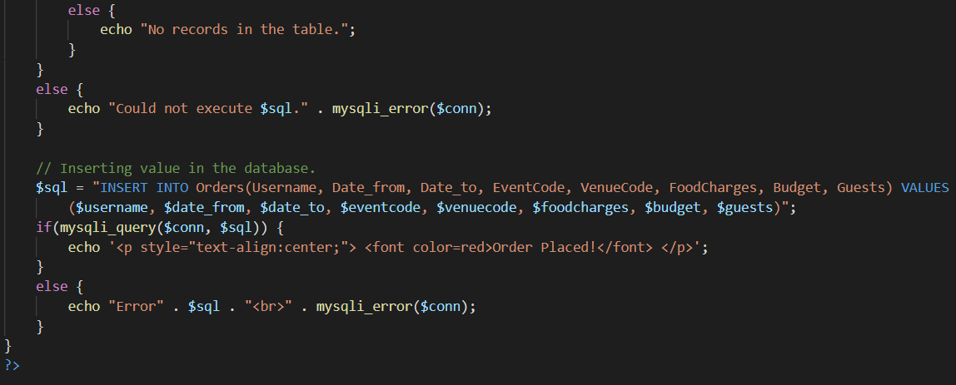

**BIBLIOGRAPHY**

* Google fonts: <https://fonts.google.com/>

Font family used:

font-family: 'Dancing Script', cursive;

font-family: 'EB Garamond', serif;

font-family: 'Libre Baskerville', serif;

font-family: 'Sacramento', cursive;

* CSS Fonts : <https://www.cssfontstack.com/>

Used to check availability of fonts on different systems

* W3school:
  + CSS defaults: <https://www.w3schools.com/cssref/css_default_values.asp>

Used to check CSS default values

* + Color-Picker : <https://www.w3schools.com/colors/colors_picker.asp>

Color reference for our website

* + Image formatting : <https://www.w3schools.com/html/html_images.asp>

Learned to use attribute property of image

* + <https://www.w3schools.com/html/html_blocks.asp>

Helped to resolve block and inline element properties

* + Iframe property : <https://www.w3schools.com/html/html_iframe.asp>

Helped to use iframes

* + HTML forms : <https://www.w3schools.com/html/html_forms.asp>

Used for to learn use of forms in better way along with their properties

* Emojipedie : <https://emojipedia.org/>

To use various emojis

* Favicon : <https://www.favicon.cc/>?

Used to create favicon

* Codeplay : <https://www.codeply.com/p?starter=Bootstrap%204>

Used to check responsiveness of divivisons

* FontAwesome : <https://fontawesome.com/>

Used for emoticon of popular apps

* ColorHunt : <https://colorhunt.co/>

Used color references for our website

* PHP Manual: <https://www.php.net/manual/en/>

Used for database connectivity (running the queries)

* Youtube:
  + <https://www.youtube.com/watch?v=-xmo2wVNpNg>
  + <https://www.youtube.com/watch?v=OK_JCtrrv-c&t=5346s>
  + <https://www.youtube.com/watch?v=tLXbTE4Mleg&t=175s>
* Database System Concepts | 6th Edition Paperback

By Abraham Silberschatz (Author), Henry F. Korth (Author), S. Sudarshan (Author)